How to Export a Connexx File

- Go to File and select “Client database import/export”

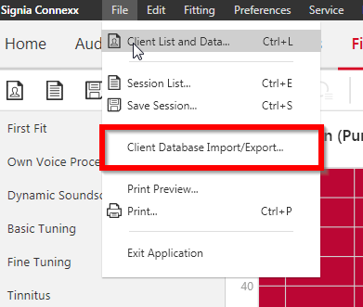

- A window will pop up. Type in the patient’s information and then click “Search Now”:

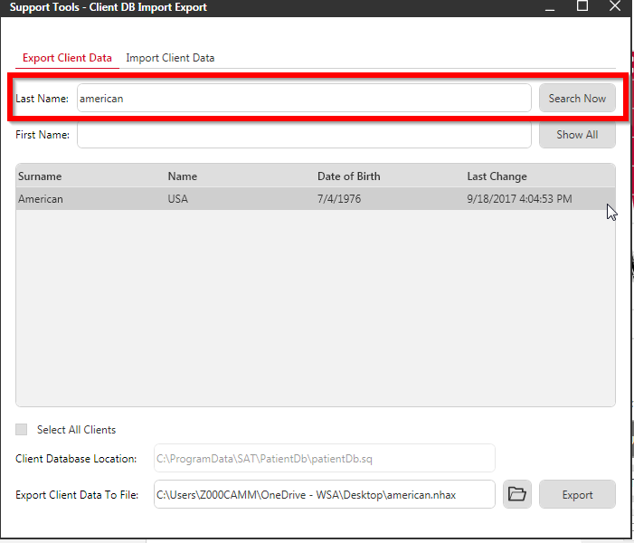

- Select the appropriate patient and verify the location to where the file will be exported

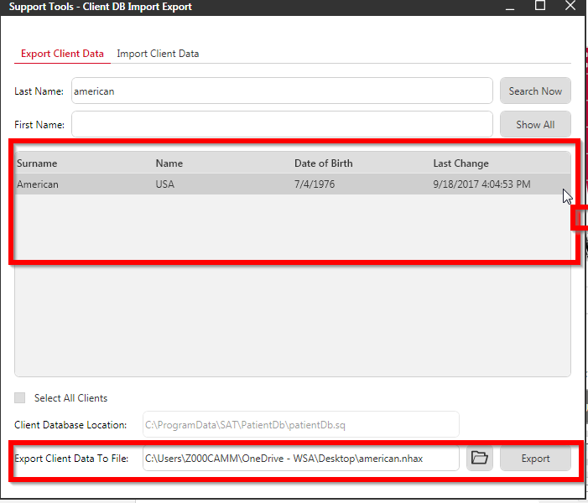

This should bring the client database screen back up. Now that the save location has been verified, simply click on the “export” button:

- Select whether the file is to be exported to another standalone Connexx or Noah and click “OK”:

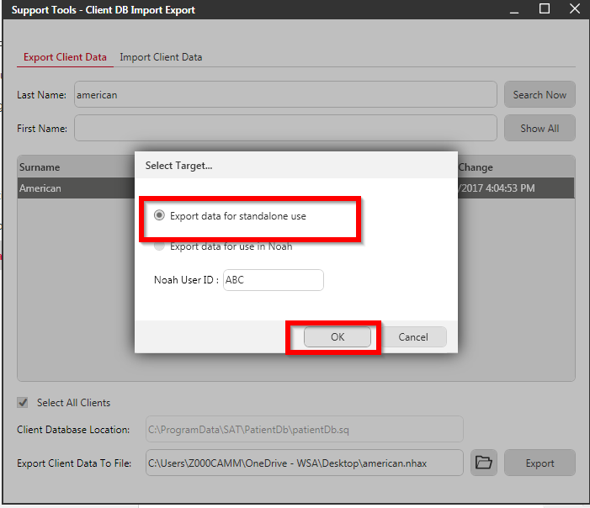

Click ok again:

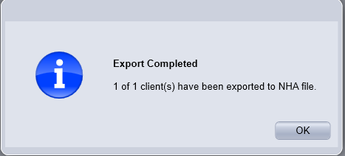

- Open a new email to send. Select “insert” and “Attach File”

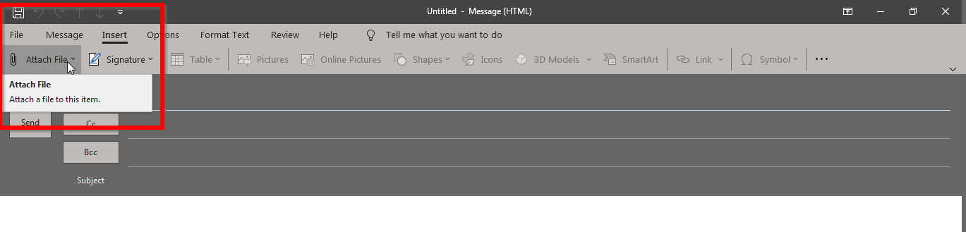
- Select the proper file and click on “open”

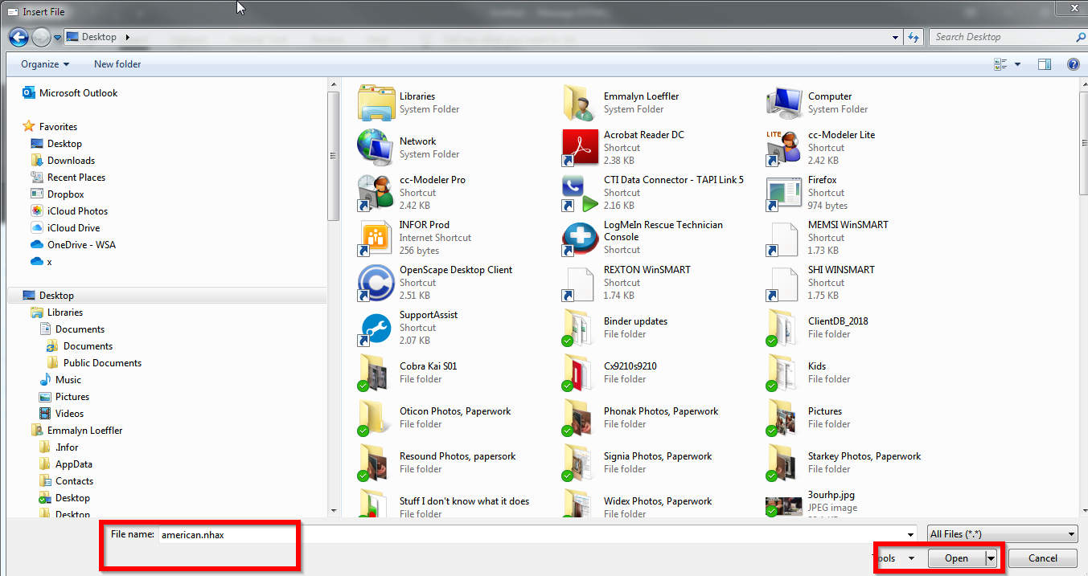

- The file is now attached to the email. Type in the desired email destination, complete the subject line and select “Send”
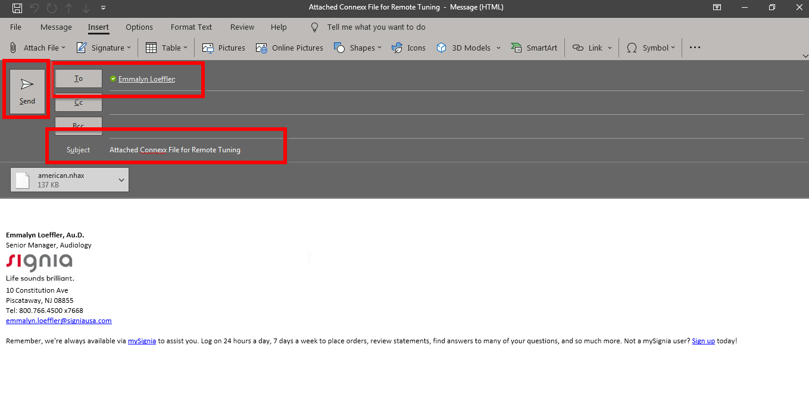

The file has been successfully exported and sent to the clinic!

